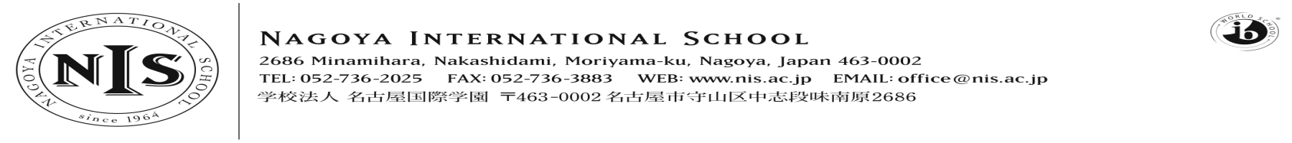
2019-2020 Positions Vacant

At NIS we are passionate about our mission – and we seek teachers and administrators who share that passion. We want our students to puzzle, wonder and question the world around them, to choose to contribute to their communities and to articulate and follow their dreams. This is encapsulated in our school motto – Inquire, Inspire, Impact. It sounds ambitious, and it is - but we think it is important, and if you do too, we want to hear from you!

Job Title: PYP PE/MYP PE & Health
NIS seeks a dynamic, enthusiastic and talented teacher of PYP PE/MYP PE & Health with the ability to help students see the subject as a window into understanding themselves and their world and as a vehicle for developing lifelong habits of healthy living.
The successful candidate will join the whole school PE and Health department to teach PE PYP (Grades 1-5) with more limited involvement with some lower MYP teaching.
NIS has a thriving PE and Athletics programme with high levels of engagement in co-curricular sports (we play in the West Japan league from Middle School). Through the PE curriculum we seek to help students make links, through concepts and transdisciplinary connections, between PE and the wider world, and in so doing, help students to better understand themselves and their identity. Consequently, the successful candidate will spend a lot of time collaborating with colleagues both vertically and horizontally to develop curriculum.
NIS is an inclusive school serving a varied array of learners and the position will suit teachers who thrive in diverse school environments and professional, highly collaborative cultures.
Applicants should consider applying based on the below requirements:
Essential:
- BA Degree in PE/Health or in Elementary Education with a strong background in PE/Health
- Valid teaching certification
- At least 2 years’ experience as a full-time teacher in an international or national school offering programmes similar to NIS, to include PE & Health
- Commitment to collaborating with colleagues to make learning connected and meaningful
- A proven commitment to professional development that has been applied to your classroom practice
- The ability to provide/consent to clear police/background and medical checks
- A commitment to inclusive education and to serving a diverse array of learners

Highly Desirable:
- Experience of teaching in the IBPYP programme as a teacher of PE/Health
- Experience of teaching in the IBMYP programme as a teacher of MYP PE & Health
- Experience as an IB workshop leader or equivalent
Please do not apply unless you meet the ‘essential’ requirements above and have read in full the details about living and working at NIS on the ‘working at NIS’ section of our website.
A spirit of collaboration, stamina, drive, a sense of humour, a passion for kids, a positive disposition and a love of professional learning are all key ingredients to the teacher toolkit at NIS. If this sounds like you – we want to hear from you!
We hope to hear from you – and thank you for your interest in NIS.

