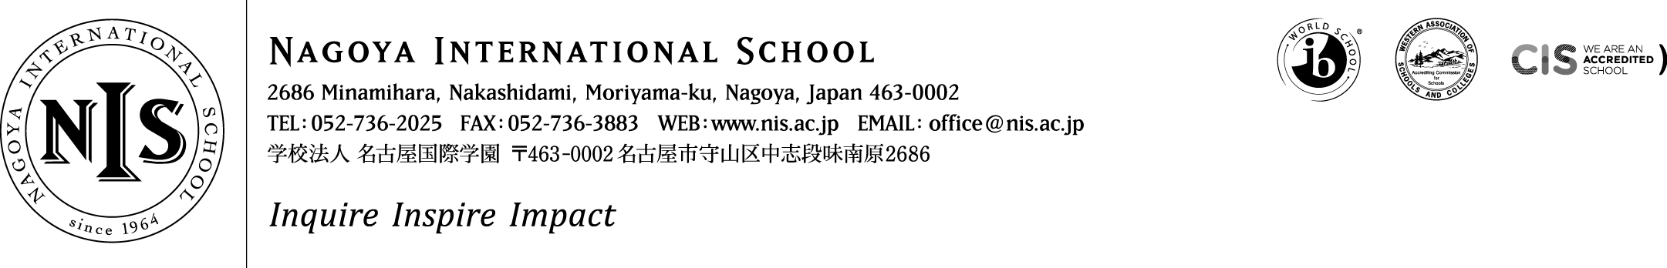

2019-2020 Positions Vacant

At NIS we are passionate about our mission – and we seek teachers and administrators who share that passion. We want our students to puzzle, wonder and question the world around them, to choose to contribute to their communities and to articulate and follow their dreams. This is encapsulated in our school motto – Inquire, Inspire, Impact. It sounds ambitious, and it is - but we think it is important, and if you do too, we want to hear from you!

Job Title: Science Lab-Technician Internship
Interns at NIS will join a collaborative, supportive and ambitious team looking to make learning ever more connected, relevant and meaningful. Through an Internship at NIS we hope to assist you in developing your personal goals while knowing that you will enrich our community and add value to professional learning and student learning here at NIS.
A Science Lab-Technician Internship involves:

- Collaborating with the science teachers to ensure that materials are prepared for experimental science
- Organise and develop a routine/ organisation of the laboratory according to the needs of the classes and teachers.
- Participating in the learning with students where possible
- Getting involved with students outside of class – coaching, arts, clubs, etc. where possible
- Becoming a full member of the NIS team and experiencing life in an international school
A spirit of collaboration, stamina, drive, a sense of humour, a passion for kids, a positive disposition and a love of professional learning are all key ingredients to the toolkit at NIS. If this sounds like you – we want to hear from you! NIS provides a salary of 1,883,000 Yen plus shared housing, flights and co-pay medical insurance.
Applicants should consider applying based on the below requirements:
Essential:
- BSc (Laboratory Science) Degree to be awarded prior to June 1
- Ability to perform basic functions of a lab technician – preparing basic materials and chemical solutions for lab work
- Ability to work collaboratively with colleagues & a passion for working with children
- Ability to provide clear police/background checks and medical clearance
- Ability to coach sports, other co-curricular activities, or to lead service learning projects
- Some experience working with children or young people
Highly Desirable:
- Prior experience as a lab technician
- Background experience working with students with special needs or English language learners
- A desire to learn more about science teaching in an international school and get thoroughly involved with the life of the science dept.
Please do not apply unless you meet the ‘essential’ requirements above and have read in full the details about living and working at NIS on the ‘working at NIS’ section of our website.
We hope to hear from you – and thank you for your interest in NIS.
M. Parr, Head of School

