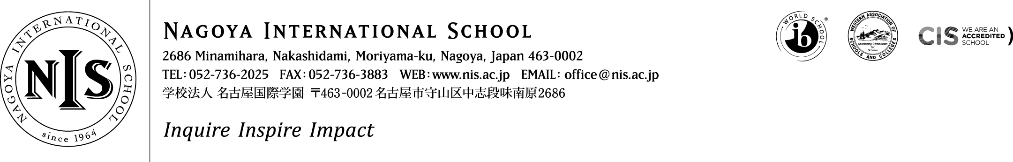

2019-2020 Positions Vacant

At NIS we are passionate about our mission – and we seek teachers and administrators who share that passion. We want our students to puzzle, wonder and question the world around them, to choose to contribute to their communities and to articulate and follow their dreams. This is encapsulated in our school motto – Inquire, Inspire, Impact. It sounds ambitious, and it is - but we think it is important, and if you do too, we want to hear from you!

Job Title: Primary School PYP Internship
Interns at NIS will join a collaborative, supportive and ambitious team looking to make learning ever more connected, relevant and meaningful. Through an Internship at NIS we hope to assist you in developing your personal goals while knowing that you will enrich our community and add value to professional learning and student learning here at NIS.
A Primary School PYP internship involves:

- Working alongside the classroom teacher to support the delivery of the curriculum. This will include working with individuals and small groups and, if mutually agreed, may include the opportunity for full class teaching. This role will also involve assisting the teacher with the routines of the job – e.g. preparing resources, marking, etc.
- Responsibility to support any specific learning or language needs for identified students in your classroom. Students are identified as needing specific support through our student referral process and part of your role will be to ensure that the needs of these students are met
A spirit of collaboration, stamina, drive, a sense of humour, a passion for kids, a positive disposition and a love of professional learning are all key ingredients to the teacher toolkit at NIS. If this sounds like you – we want to hear from you! NIS provides a salary of 2,000,000 Yen plus shared housing, flights and co-pay medical insurance.
Applicants should consider applying based on the below requirements:
Essential:
- BA Degree to be awarded prior to June 1
- Teaching certification to be awarded prior to Aug 1
- Ability to work collaboratively with colleagues
- A passion for working with children and to pursue a career in education
- Ability to provide clear police/background checks and medical clearance
- Ability to coach sports, other co-curricular activities, or to lead service learning projects
- Some experience working with children or young people
- A commitment to inclusive education and to serving a diverse array of learners
Highly Desirable:
- Background experience working with students with special needs or English language learners
Please do not apply unless you meet the ‘essential’ requirements above and have read in full the details about living and working at NIS on the ‘working at NIS’ section of our website.
NIS prefers to appoint via face to face interview where possible. Therefore, if you are attending the search/CIS fair in Bangkok (Jan) or Cambridge (Jan) AND/OR can be available to meet in/near those cities at the time of the fair please send an email to Matthew Parr, Head of School (headofschool@nis.ac.jp) indicating your interest and including the words ‘FAIR ATTENDEE’ in the subject header.
If you are not attending these venues but still wish to apply, of course your application will still be welcome, however, please understand you may not receive an immediate response/interview request.
We hope to hear from you – and thank you for your interest in NIS.
M. Parr, Head of School

