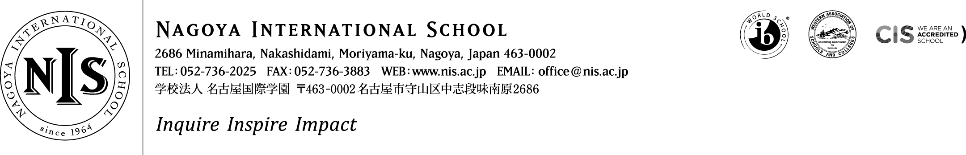

2019-2020 Positions Vacant

At NIS we are passionate about our mission – and we seek teachers and administrators who share that passion. We want our students to puzzle, wonder and question the world around them, to choose to contribute to their communities and to articulate and follow their dreams. This is encapsulated in our school motto – Inquire, Inspire, Impact. It sounds ambitious, and it is - but we think it is important, and if you do too, we want to hear from you!

Job Title: Elementary School Early Years Programme (Kindergarten) Teacher
The successful candidate will join a collaborative, supportive and ambitious Early Years team looking to make learning ever more connected, relevant and meaningful to the child. NIS is a fully authorised PYP school, and our Early Years’ department builds the PYP programme upon the foundations of a Reggio Emilia approach which places the needs of the child firmly at the centre. A strong commitment to the rights of the child, the voice of the child and the role that teachers, parents and the environment have to play in the developmental growth of children are core to our central philosophy. We seek experienced and passionate early childhood educators to help us take the next concrete steps in our journey towards building the PYP-Reggio programme we dream of!

The department is housed in its own well equipped open planned building which is an invitation to inquiry and play-based learning. The team of teachers is supported by teaching assistants to ensure a favourable student: adult ratio.
A spirit of collaboration, stamina, drive, a sense of humour, a passion for kids, a positive disposition and a love of professional learning are all key ingredients to the teacher toolkit at NIS. If this sounds like you – we want to hear from you!
Applicants should consider applying based on the below requirements:
Essential:
- BA Degree & valid certification to teach at the Early Years level
- AT least 2 years’ experience as a full-time teacher in an international/national school offering programmes similar to NIS (Reggio, PYP)
- At least 2 years’ experience of the Reggio Emelia approach to early childhood education
- Ability to work in a highly collaborative open-plan learning envoronment with colleagues
- A proven pedagogy which embraces inquiry and a notion of students constructing their own meaning in context
- A proven commitment to professional development that has been applied to your classroom practice
- Ability to provide clear police/background checks and medical clearance
- Teaching experience in at least one of the PYP or a Reggio environment
- A commitment to inclusive education and to serving a diverse array of learners
Highly Desirable:
- Experience of integrating both the IBPYP & Reggio Emilia
- At least 5 years’ experience in the Early Years/Kinder classroom, with a proven track record of reflective practice and professional growth over that time

Please do not apply unless you meet the ‘essential’ requirements above and have read in full the details about living and working at NIS on the ‘working at NIS’ section of our website.

A spirit of collaboration, stamina, drive, a sense of humour, a passion for kids, a positive disposition and a love of professional learning are all key ingredients to the teacher toolkit at NIS. If this sounds like you – we want to hear from you!

We hope to hear from you – and thank you for your interest in NIS.

